Colligative Properties
[Colligatille : from Latin. = Co mean „together’; ligare means „to bind‟.]
Colligative properties are those properties which depend only upon the number of solute particles in a solution irrespective of their nature.

Relative Lowering of Vapour Pressure
It is the ratio of lowering in vapour pressure to vapour pressure of pure solvent. The relative lowering in vapour pressure of solution containing a nonvolatile solute is equal to the mole fraction of solute in the solution.
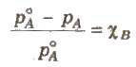
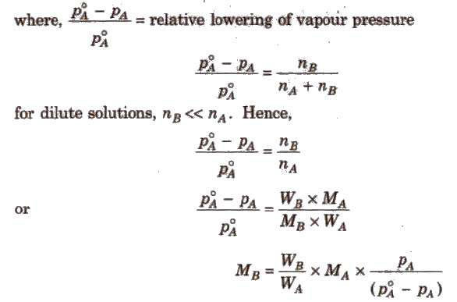
Above expression is used to find the molecular weight of an unknown solute dissolved in a given solvent. Where, W_{B} and W_{A} = mass of Solute and solvent respectively. M_{B} and M_{A} = molecular weight of solute and solvent respectively.
Ostwald and Walker method is used to determine the relative lowering of vapour pressure.

Elevation in Boiling Point (ΔT_{b})
Boiling point of a liquid is the temperature at which its vapour pressure becomes equal to the atmospheric pressure. As the vapour pressure of a solution containing a nonvolatile solute is lower than that of the pure solvent, it boiling point will be higher than that of the pure solvent as shown in figure. The increase in boiling point is known as elevation in boiling point, ΔT_{b}
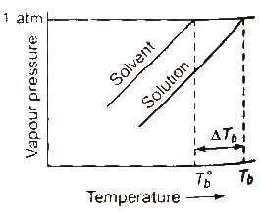
ΔT_{b} = T_{b} – T°_{b} ΔT_{b} = K_{b} m (where; m = molality)
K_{b} is molal elevation constant or ebullioscopic constant. Molecular mass of solute can be calculated as
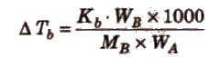
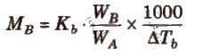
where, W_{B} and W_{A} = mass of solute and solvent respectively.
K_{b} has units of K / m or K kg mol⁻¹, for water, K_{b} = 0.52 K kg mol⁻¹
The boiling point elevation of a solution is determined by
(i) Landsberger‟s method(ii) Cottrell‟s method

Depression in Freezing Point (ΔT_{f})
Freezing point of a liquid is the temperature at which vapour pressure of the solvent in its liquid and solid phase become equal. As we know that vapour pressure of solution containing non-volatile solute is lower than that of pure solvent, solid form gets separated out at a lower temperature as shown in the figure.
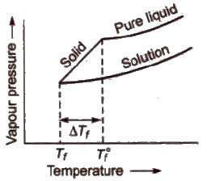
This decrease in freezing point of a liquid is known as depression in freezing point.
Depression in freezing point (ΔT_{f}) = T°_{f} – T_{f}
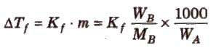
To find molecular mass of solute,
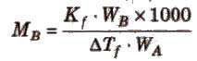
where, K_{f} is molal depression constant or cryoscopic constant.
K_{f} has units of K / m or K kg mol⁻¹.
Ethylene glycol is usually added to water in the radiator to lower its freezing point. It is called antifreeze solution.
[Common salt (NaCI) and anhydrous CaC12 are used to clear snow on the roads because they depress the freezing point of water. The freezing point depression is determined by Beckmann method or Rast method.]
Calculations of molal elevation constant (K_{b}) and molal depression constant (K_{f})
